MODELING NATURAL SELECTION
Graduate Partners in Science Education
LEARNING OBJECTIVES:
Students will be able to demonstrate mastery of the following objectives and associated state and national standards:
- Design hypotheses and predictions
  - MS-LS4-1
  - MS-LS4-6
  - U1
- Collect and record data
  - MS-LS4-1
  - U1
- Present and discuss results with classmates
  - MS-LS4-1
  - U1
- Communicate a basic understanding of the principles driving natural selection
  - MS-LS4-4
  - MS-LS4-6
  - L3
  - L4
National Science Standards (Grades 5-8):
- Science knowledge is based upon logical and conceptual connections between evidence and explanations. (MS-LS4-1)
- Analyze and interpret data to determine similarities and differences in findings. (MS-LS4-1)
- Natural selection leads to the predominance of certain traits in a population, and the suppression of others. (MS-LS4-4)
- Adaptation by natural selection acting over generations is one important process by which species change over time in response to changes in environmental conditions. Traits that support successful survival and reproduction in the new environment become more common; those that do not become less common. Thus, the distribution of traits in a population changes. (MS-LS4-6)
- Phenomena may have more than one cause, and some cause and effect relationships in systems can only be described using probability. (MS-LS4-4),(MS-LS4-6)

Arizona State Science Standards (Grades 5-8):
- L3: Genetic information is passed down from one generation of organisms to another.
- L4: The unity and diversity of organisms, living and extinct, is the result of evolution.
- U1: Scientists explain phenomena using evidence obtained from observations and or scientific investigations. Evidence may lead to developing models and or theories to make sense of phenomena. As new evidence is discovered, models and theories can be revised.
MATERIALS:
- Patterned paper (1 per pair, at least 5 unique patterns total)
- Bag of paper dots (1 per pair, each bag containing 20 dots total)
  - 4 dots of each of the 5 unique color patterns
- Extra dots of each color
- Bag of species (1 per pair, each bag containing 20 organisms total)
  - 4 organisms each of 5 different species - 4 pom poms, 4 pennies, 4 paper dots, 4 beads, 4 grains of rice
- Clothespins, chopsticks, or other “grabbing”/clip tool (1 per pair)
5 min. | Engage  - Provide a bowl or bag of candy - some classic favorites like Snickers, Skittles, etc. and some classic rejects like candy hearts, Raisinets, etc. Make sure they’re in equal proportions and you know how many of each kind you put in.  - Let each student take 2 candies. Create a table or graph to show the change from the starting candy population to the final candy population.  - Likely, the “gross” candies will be left over. Why?  - Explain “selection” in this context. Students select the candies they like, so more of the “gross” ones are left and can “reproduce”  - You can fill the bowl with more candy, but only the gross ones! (They can have more of the good candy before moving on)
10 min | Explore  - Have pairs of students conduct Experiment 1  - Explain the set-up for the experiment: what does the population look like?  - Have students generate questions and hypotheses  - Record a prediction: How will the final population look different from the beginning?  - Run Experiment 1 and record data in their packet
10 min | Explain  - Allow students to graph their data  - Have students discuss with another group any differences they see between their results  - Have each pair discuss and record conclusions for Experiment 1
10 min | Expand  - Have pairs of students conduct Experiment 2, now considering a more diverse population and limited predator  - Explain the set-up for the experiment: what does the population look like? What do the predators look like?  - Have students generate questions and hypotheses  - Record a prediction: How will the final population look different from the beginning? Why?  - Run Experiment 2 and record data in their packet
10 min | Evaluate  - Allow students to graph their data  - Have students discuss with another group any differences they see between their data  - Have each pair discuss and record conclusions for Experiment 2  - Were the conditions in Experiment 2 different from Experiment 1? Why did those differences matter? Discuss in groups of 4 (two pairs)

Notes for instructors:
- Incorporated learning theories:
  - Social learning theory (SLT): Students will work in pairs and share/discuss their results with another pair to encourage them to challenge each others’ lines of thought
  - Developmental learning theory (DLT): This is a difficult concept to think about in an abstract manner, and because students of this age group are between concrete operational and formal operational thinking, they may struggle with an abstract activity. This is a tactile, visual representation of natural selection, so it is less abstract, but it does push their formal operational thinking by asking them to make predictions and compare them to actual results.
- Summative and Formative Assessment:
  - Formative: Students will brainstorm questions, hypotheses, and predicted results in pairs. This informs the instructor as to what students know coming in and how they think about the underlying processes of natural selection.
  - Summative: Students collect data and use that data to draw conclusions. They will discuss differences between predictions and the actual result, as well as discuss and record if and why differences were observed between groups.

DESCRIPTION OF ACTIVITY:
Prior to class:
- Prep “habitats” – enough for each pair to have their own habitat
- Prep “creatures” – prep the following for pair
  - Color selection:
    - 20 creatures – 4 each of 5 “phenotypes”
      - 4 dots of color A
      - 4 dots of color B
      - 4 dots of color C
      - 4 dots of color D
      - 4 dots of color E
    - large paper for habitat (at least enough different colors to match the 5 different organism colors throughout the class)
    - extra bags of each dot color
  - Species selection:
    - 20 creatures – 4 each of 5 “species”
      - 4 pom poms
      - 4 pennies
      - 4 paper circles
      - 4 beads
      - 4 pieces of pasta
    - large paper for habitat
    - extra bags of each “species”
    - chopsticks/clothespin
Experiment 1:
- Partner up
- One partner scatters creatures onto habitat while other (the “predator”) looks away
- Turn down the lights to simulate low visibility in the wild
- The “predator” turns around and removes creatures one by one for 5 seconds
- Creatures “reproduce” - for every dot left in the habitat, put in a matching dot to double the population, now of different color proportions.
- Record the number of each color before repeating steps 2-5, until 5 rounds have been completed.
- Make a bar graph to compare the population percentages of rounds 1 and 5
- Compare your results with another pair. Are your results the same or different? Why?
Experiment 2:
- Partner up
- One partner scatters creatures onto habitat while other (the “predator”) looks away
- Turn down the lights to simulate low visibility in the wild
- The “predator” turns around quickly and uses the clothespin/chopsticks to remove “creatures” from the habitat as quickly as they can for 5 seconds
- Creatures “reproduce” - for every item left in the habitat, put in a matching creature to double the population, but now of different proportions of each species
- Record the number of each species before repeating steps 2-5, until 5 rounds have been completed
- Make a bar graph to compare the population of rounds 1 and 5
- Compare your results with another pair. Are your results the same or different? Why?

STUDENT PACKET BEGINS ON THE FOLLOWING PAGE

Experiment 1: Single Species
Question
Proposed Explanation (Hypothesis)
Predicted result
Experimental Procedures
- Partner up
- One partner scatters creatures onto habitat while other (the “predator”) looks away
- Turn down the lights to simulate low visibility in the wild
- The “predator” turns around and removes creatures one by one for 5 seconds
- Creatures “reproduce” - for every dot left in the habitat, put in a matching dot to double the population, now of different color proportions.
- Record the number of each color before repeating steps 2-5, until 5 rounds have been completed.
- Make a bar graph to compare the population percentages of rounds 1 and 5
- Compare your results with another pair. Are your results the same or different? Why?

Number of dots of each color at the start of each generation
Color | Round 1 | Round 2 | Round 3 | Round 4 | Round 5
 | 4
 | 4
 | 4
 | 4
 | 4
Totals | 20

Percentage of each color at the start of each generation
Color | Round 1 | Round 2 | Round 3 | Round 4 | Round 5
 | 20%
 | 20%
 | 20%
 | 20%
 | 20%
Totals | 100%

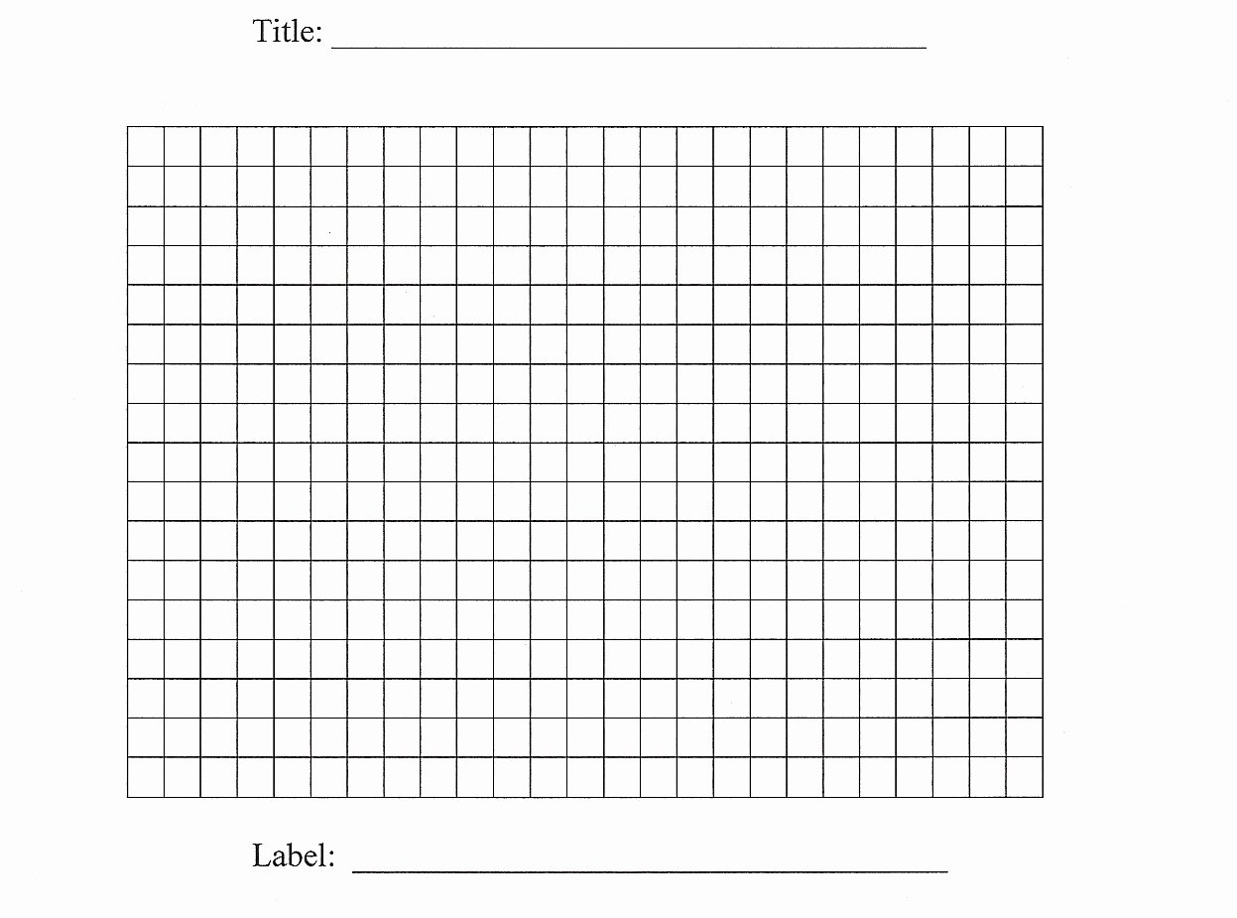

Actual Result

Conclusion

Experiment 2: Different Species
Question
Proposed Explanation (Hypothesis)
Predicted result
Experimental Procedures
- Partner up
- One partner scatters creatures onto habitat while other (the “predator”) looks away
- Turn down the lights to simulate low visibility in the wild
- The “predator” turns around quickly and uses the clothespin/chopsticks to remove “creatures” from the habitat as quickly as they can for 5 seconds
- Creatures “reproduce” - for every item left in the habitat, put in a matching creature to double the population, but now of different proportions of each species
- Record the number of each species before repeating steps 2-5, until 5 rounds have been completed
- Make a bar graph to compare the population of rounds 1 and 5
- Compare your results with another pair. Are your results the same or different? Why?

Number of dots of each color at the start of each generation
Color | Round 1 | Round 2 | Round 3 | Round 4 | Round 5
 | 4
 | 4
 | 4
 | 4
 | 4
Totals | 20

Percentage of each color at the start of each generation
Color | Round 1 | Round 2 | Round 3 | Round 4 | Round 5
 | 20%
 | 20%
 | 20%
 | 20%
 | 20%
Totals | 100%

Actual Result

Conclusion

