Jonathan Jackson
Title: “Race to Displace”* modified for the Sonoran Desert in Arizona
*This lesson has been adapted to the local biome from the following published lesson and structured to conform to a 5E model as was requested by a Director of GPSE.
Hopwood, J. L., Flowers, S. K., Seidler, K. J., & Hopwood, E. L. (2013). Race to Displace: A Game to Model the Effects of Invasive Species on Plant Communities. The American Biology Teacher, 75(3), 194-201.
Grade Level Band: 6th -12th Grade
Target Grade Level: 7th Grade
Recommended number of class periods: 2+
Lesson Objectives:
- Students will learn about the effects of invasive plant species in Arizona on the native plants species and the role of ecosystem management by playing repeated iterations of a board game designed to simulate and model complex species interactions in a local ecological environment.
Arizona State Science Standards Addressed: (For Grade 7)
- All applicable standards listed below for grade 7, with standards of main focus in bold.
Strand 1: Inquiry Process
Concept 1: Observations, Questions, and Hypothese
PO2. Select appropriate resources for the background information related to a question.
Concept 2: Scientific Testing (Investigating and Modeling)
PO 3. Conduct a controlled investigation, utilizing multiple trials, to test a hypothesis using scientific processes.
PO 5. Keep a record of observations, notes, sketches, question and ideas using tools such as written and/or computer logs.
Concept 3: Scientific Testing (Investigating and Modeling)
PO 1. Analyze data obtained in a scientific investigation to identify trends.
PO 2. Form a logical argument about a correlation between variables or sequence of events (e.g., construct a cause-and-effect chain that explains a sequence of events).
PO 3. Analyze results of data collection in order to accept or reject the hypothesis.
PO 5. Formulate a conclusion based on data analysis.
PO 6. Refine hypotheses based on results from investigations.
PO 7. Formulate new questions based on the results of a previous investigation.

Strand 2: History and Nature of Science
Concept 2: Nature of Scientific Knowledge
PO 3. Apply the following scientific processes to other problem solving or decision making situations:

• observing
• questioning
• communicating
• comparing
• measuring
• classifying
• predicting
• organizing data
• inferring
• generating hypotheses
• identifying variable

Strand 3: Science in Personal and Social Perspectives
Concept 1: Changes in Environments
PO 1. Analyze environmental risks (e.g., pollution, destruction of habitat) caused by human interaction with biological or geological systems.
PO 2. Analyze environmental benefits of the following human interactions with biological or geological systems:
• reforestation
• habitat restoration
• construction of dams
PO 3. Propose possible solutions to address the environmental risks in biological or geological systems.
Strand 4: Life Science
Concept 3: Populations of Organisms in an Ecosystem
PO 2. Explain how organisms obtain and use resources to develop and thrive in:
• niches
• predator/prey relationships
PO 3. Analyze the interactions of living organisms with their ecosystems:
• limiting factors
• carrying capacity
PO 4. Evaluate data related to problems associated with population growth (e.g., overgrazing, forest management, invasion of non-native species) and the possible solutions.
PO 5. Predict how environmental factors (e.g., floods, droughts, temperature changes) affect survival rates in living organisms.
PO 6. Create a model of the interactions of living organisms within an ecosystem.

Teacher Resources about Topics Relevant to this Lesson:
- A good basic refresher regarding invasive species can be found at the following link
http://www.desertmuseum.org/invaders/invaders_about.php#intro
- Saguaro
http://www.desertmuseum.org/kids/oz/long-fact-sheets/Saguaro%20Cactus.php
- Buffelgrass
http://www.buffelgrass.org/
- Sahara Mustard
http://www.desertmuseum.org/invaders/invaders_saharamustard.php
- Sand Verbena
http://www.desertusa.com/flowers/desert-sand-verbena.html
(Not much information at this link. If more information is found at another link please share with Jon Jackson at joncolej@asu.edu.)
- Salt Cedar
http://www.desertmuseum.org/invaders/invaders_tamarisk.php
- Gooding’s Willow
http://www.arizonensis.org/sonoran/fieldguide/plantae/salix_gooddingii_p2.html

Notes:
- All suggested questions and student prompts are emboldened.
- Its recommended that teacher utilizes the HRASE (history, relationship, application, speculation, explanation) question strategy congruent with research on learning and development, which was developed to help teacher organize their questions while developing students problem solving skills (Penick, 1996).
- Penick, J. E. (1996). Questions Are the Answers. Science Teacher, 63(1), 26-29.

Engagement | Objective:  The students will report on what they know about plants in general and about their own experiences and knowledge of plants in Arizona in particular while being asked to speculate about how plants can interact with each other.  Purpose:  The purpose of this brief discussion is threefold.  First, eliciting student knowledge about plants in general will serve to validate the “action cards” to be used in the simulation/game later. Additionally, allowing the instructor to identify any gaps in knowledge that must be immediately addressed so as to understand the later activities.  Second, eliciting student knowledge and experience with plants in Arizona will elicit personal feelings and tie the lesson to personal experiences for the students.  Third, eliciting student knowledge about Arizona plants in particular while asking students to speculate about how plants can interact with each other will draw students’ attention to gaps in their understanding to be investigated in the activities that follow.  Materials:  - White board.  - Power Point with pictures of plants found in Arizona (optional).  Instructional Sequence:  - Teacher will provide a brief overview of activity and the goals for the activity. Be sure to mention to students that we will be using their knowledge to make sense of a simulation or model taking the form of a game.  - Write on the white board to column headers “General plant knowledge.” Record student response on the white board.  (Questions that follow ensure all “action cards” used in the game/simulation are understood.)  - Begin by asking “What do you know about plants?”  - Ask “What do plants need to grow and thrive?” Be sure that students describe sunlight, moisture, and nutrients.  - Ask students “What things come from plants?” Wait for them to mention seeds or prompt them to consider seeds by moving on to step 5.  - Follow this up by asking “Why are seeds important?”, “What things eat seeds?”, and “How does it affect plants if their seeds are eaten?”  - Ask if “What do you know about pollen?” If nothing or not much then for now simply inform them that generally pollen is necessary to make lots of healthy seeds.  - Optional: Turn on power point showing pictures of plants found in Arizona, Tempe, and even at their school (time permitting to get) at the beginning of the activity and leave on during initial discussion.  - Ask students “What do you know about plants in Arizona?” A couple ways you could use the power point is to make sure it has pictures of seeds in it. Another thing to do might be to stop on pictures of plants used in the activity (e.g. a saguaro) and ask students “What do you know about saguaros?” If you take a picture of a plant in a the classroom or on the playground ask “What do you know about this plant?”  - There is a lot here, but keep this discussion somewhat fast paced, taking about 10 minutes. Wrap the discussion up by asking about how plants might compete. Ask “What do we mean when we say two things are competing?”, “How might you suppose plants compete with each other?”, What might happen to an Arizona Rose if a Mesquite Tree grows up beside it and blocks out much more and more sunlight?”  - Tell students that they will now be playing a game that uses all things we just talked about to model how plants interact with each other.
Exploration | Objective:  Students will relate their understanding of plant biology to the simulation/game.  Students will begin learning about their chosen plant.  Students will get experience working with a probabilistic model (i.e. the game).  Purpose:  The purpose of this activity twofold.  First, get students to start thinking about how models and simulations are similar to games.  Second, get students thinking about how chance, environment factors, and species interactions affect the success of different plant species.  Materials:  All materials can be cheaply printed off. Lamination and color printing are optional.  Game and materials are directly inspired by the Race to Displace activity published in the American Biology Teacher but have been adapted for Arizona desert ecosystem, as opposed to a prairie and woodland ecosystem used in the original activity (Hopwood, et al., 2013)  Action Cards from the original activity can be used as is. They can be found and printed off at…  http://schoolpartnership.wustl.edu/instructional-materials/race-to-displace/  Plant Character Profiles, and Game Board have been adapted for plants found in desert ecosystems of Arizona. You can find these in the Appendix at the end and print these off.  Plant Tokens may require some improvisation. Any uniquely identifiable objects may do. One option is to print off the Plant Token sheet with a picture of the plant and its name also included in the Appendix.  Data Sheet to rank the success of species over multiple trials (i.e. games) are adopted from Hopwood, et al. (2013) and also included in the Appendix.  Game Rules are also included in the Appendix. The game is fairly simple to learn and follows essentially the same game mechanics as the popular kids board game, Candyland.  Hopwood, J. L., Flowers, S. K., Seidler, K. J., & Hopwood, E. L. (2013). Race to Displace: A Game to Model the Effects of Invasive Species on Plant Communities. The American Biology Teacher, 75(3), 194-201.  Instructional Sequence:  - Explain the rules of “Race to Displace”. Tell students it is similar to playing Candyland, except that the characters (i.e. plants) that they choose to play will have some impact on the outcome of the game.  - Have students get in groups of 4 to 6 people.  - Have students play between 3-4 games.  - Warn students it may not seem like the game is “fair” for each plant. Do not get annoyed or discouraged.  - Instead keep track of the ranks of each player after the game. Play as the same plant over and over again. Try to see if some plants seem to have an advantage.  - Make sure students record the rank of species success after each game in a Data Sheet.  - The game rules from the original activity follow. Exceptions and notes are italicized and emboldened.  Rules  The object of the game is to be the plant species with the largest population in the community. The species that reaches the finish first has the largest population size and wins. Students should play the game at least three times and track the ranking of each plant in each round (see {Data Sheets}). {Optional rules removed for use during elaboration phase of this lesson plan.}  (1) Each player chooses a Plant Token that represents their species identity for the duration of the game and then finds the corresponding Plant Information Card and looks it over to briefly become acquainted with their species’ unique characteristics.  Place all Plant Tokens in the “Start” area.  (2) Shuffle the Action Cards and place them near the game board.  (3) Players draw an Action Card at the beginning of each turn and follow the instructions on it to move around the board. Turns will occur in the following order: {Plants will have been changed, but native species go first, then non-native species. Remember at this time students do not necessarily know which is which. So Saguaro, Gooding’s Willow, Sand Verbena, and then Sahara Mustard, Salt Cedar, and Buffelgrass.}  (4) When a player lands on a space that contains an event, they should refer to their Plant Information Card, which will tell them how to respond. For example, when the player representing {Saguaro} lands on a “produce seeds” space, they should move an additional three spaces ahead.  (5) Some Action Cards are competition cards, which are relevant if two or more players are on the same space. These players should refer to their Plant Information Cards for direction on how to proceed. For example, if the player representing Chinese lespedeza and the player representing black-eyed Susan are on the same space, they compete, the result being that lespedeza moves forward two spaces and black-eyed Susan moves back one. If a player draws a competition card but is not sharing the space, the player stays in place. If a player is sharing the space with more than one other player, they must compete with each.  (6) If the Action Cards run out, shuffle and reuse the discarded cards.  (7) The first player to reach the Finish area wins! After a student reaches the Finish area, have students rank the plants from the largest populations (those closest to the finish) to the smallest (those closer to the starting point). Use Data Sheets to collect data.
Explanation | Objective:  Students will learn about each of their selected plants, including which are invasive and which are non-native.  Students will pool group data into a single set of class data and identify general patterns in the class data and interpret the implications.  Purpose:  There are three goals to this activity.  First, provide students with formal knowledge about the plants in the game.  Second, have students identify what plants tended to be successful given the conditions simulated by the action cards.  Third, show students how the game/model does mimic what is known about the effect of invasive species on native species.  Materials:  - White boards  Instructional Sequence:  - Have students pool their data on the white board.  - Ask students “Which plants tended to be more successful?” and “Which plants tended to be less successful?” “What is your evidence for such conclusions?”  - Ask students “Why do certain plants tended to be more successful?” “What tended to happen between native and invasive species when Competition Cards were drawn?”  - Ask students “If the movement of the plants on the board was indicative of population size then what did it indicate when plants moved back and forth?”  - Provide students with Plant Character Profiles. Have students read their plant character profiles and then read their plant character profiles with their group.  - Provide additional information regarding how the invasive are pest species and limit biodiversity. Be sure students understand where invasive species come from and the human cause of such invasions. Note that not all non-native plants are considered a nuisance but the ones that are a problem are often referred to as noxious invasive species.  - Tell students to look again at the class data, then ask “What might happen to the populations of native species if these trends continued?” “What does the word extinct mean?” “Why do you or don’t you think that the native species might go extinct in the long run if something isn’t done to address the problem?”
Elaboration | Objective: Have students modify the game/simulation to see what effect that will have the outcome of simulation.  Purpose: The purpose of this activity is to get students thinking about how create and modify simulations to explore alternative effects, while also considering practical options for dealing with an environmental problem.  Materials:  - Take the optional Manage Habitat cards from the original activity. Be sure to have at least 8 for each group.  Instructional Sequence:  - Ask “After looking at the back of your plant profile cards, what are something things that could be done to control and reduce the populations of noxious invasive plants?”  - Have students generate a list of things that could be done to limit the spread of noxious invasive species. Record their ideas on a white board as a reference.  - Give the following Manage Habitat card. Note that exotic is also sometimes used to refer to noxious invasive species. Feel free to point out the problem with such a broad term.  “Manage Habitat:  Restoration ecologist attempts to control population of invasive plant species by selectively spraying herbicide on exotic plants.  If you are an exotic plant move 2 spaces back.  If you are a native plant stay put.”  - Have students play 2 -3 games with the new “Action Cards” added to their events deck.  - Have each group make specific predictions about what effect and how big an effect adding the new cards will have on their simulation.  - Make sure students record the rank of species success after each game in a data sheet.
Evaluation | Objective: Have students re-evaluate the simulation and its implications for pest management.  Purpose: Have students’ summarize their understanding of the simulation and recognize the probabilistic nature of species interactions and even pest management.  Materials:  - Whiteboard  Instructional Sequence:  - Have students add their new results to the class data.  - Ask students “What effect the manage habitat cards had on the simulation?”  - Ask students “Were the invasive species ever more successful than the native species, once the manage habitat cards were introduced?” (Answer will almost certainly be yes given the probabilistic nature of the game.)  - Ask students “Why despite the new cards were invasive species still sometimes successful?” “What does that mean for conservation management?”  - Ask students “How hard do you suppose it would be to fully get rid of an invasive species once introduced?” “How could their competitive abilities make this difficult?”  - Ask students speculate “Given what you have learned simulating plant competition in this game. What do you suppose will happen to invasive species in the long-run if there was no human management of the habitats?”
Possible Alternatives and Troubleshooting:
- In my experience how long it will take to teach the game and how long each run of the game/model takes can vary widely between grades. This doubtless is affected by the age level of the students and the level of engagement in the activity. Do not be surprised if just teaching the game and playing one game take one period. Repeated runs of the game though are important.
- If you must limit this activity to one class period then it is recommended that you create enough boards for every two students and that half the class gets a set of cards without “Managed Habitat” card and the other half of the class gets cards with extra copies of the “Managed Habitat” card. Pool the result for the two groups and discuss the average difference. This will of course increase the importance of sharing and analyzing class data as you will be more dependent upon chance and summation of multiple groups to see the expected phenomena.
- If need be and possibly as an alternative exercise in its own right you may vary the number of “Manage Habitat” cards that students have in their decks.
- If you have two or three class periods available, then consider not introducing the “Manage Habitat” card until the second day. This of course will require the recording and keeping of class data from the previous period. An advantage to this strategy is that it might allow a little extra time for a more involved discussion about strategies for managing habitats. Such a discussion could serve as the introduction to the second class period. This option is really only recommended if students are interested, engaged and enjoying the simulations of the game.

- Another option that might would work well with the previous suggest of doing this activity for two days would be to no give students the “Manage Habitat” cards, but through careful discussion guide the students to create such cards on their own. This would be recommended for more advanced students. Additionally, students might try to simulate different management strategies. Be sure though that they have a clear and defensible line of reasoning for how different “Manage Habitat” cards vary in effect. Students might make “Apply herbicide” cards or “Hand cutting” cards for example, with the former card reducing population considerably for all species and the later only affecting invasive species. How you might model the extra cost of man power with a “Hand Cutting” card might be an interesting challenge.
- Another option to reduced time might be to have half the class play the game regularly and the other half of the class play with the Manage Habitat cards. While this theoretically would work the same as reducing the number of games students play it would mean that only half the class would have hands on experience seeing what effect the “Manage Habitat” cards would have and even these students might not realize what effect these cards have on game play given their lack of experience with normal game play. Again if this option is selected then the pooling and careful analysis of class data will be of greater importance to discern expected trends.

Appendix
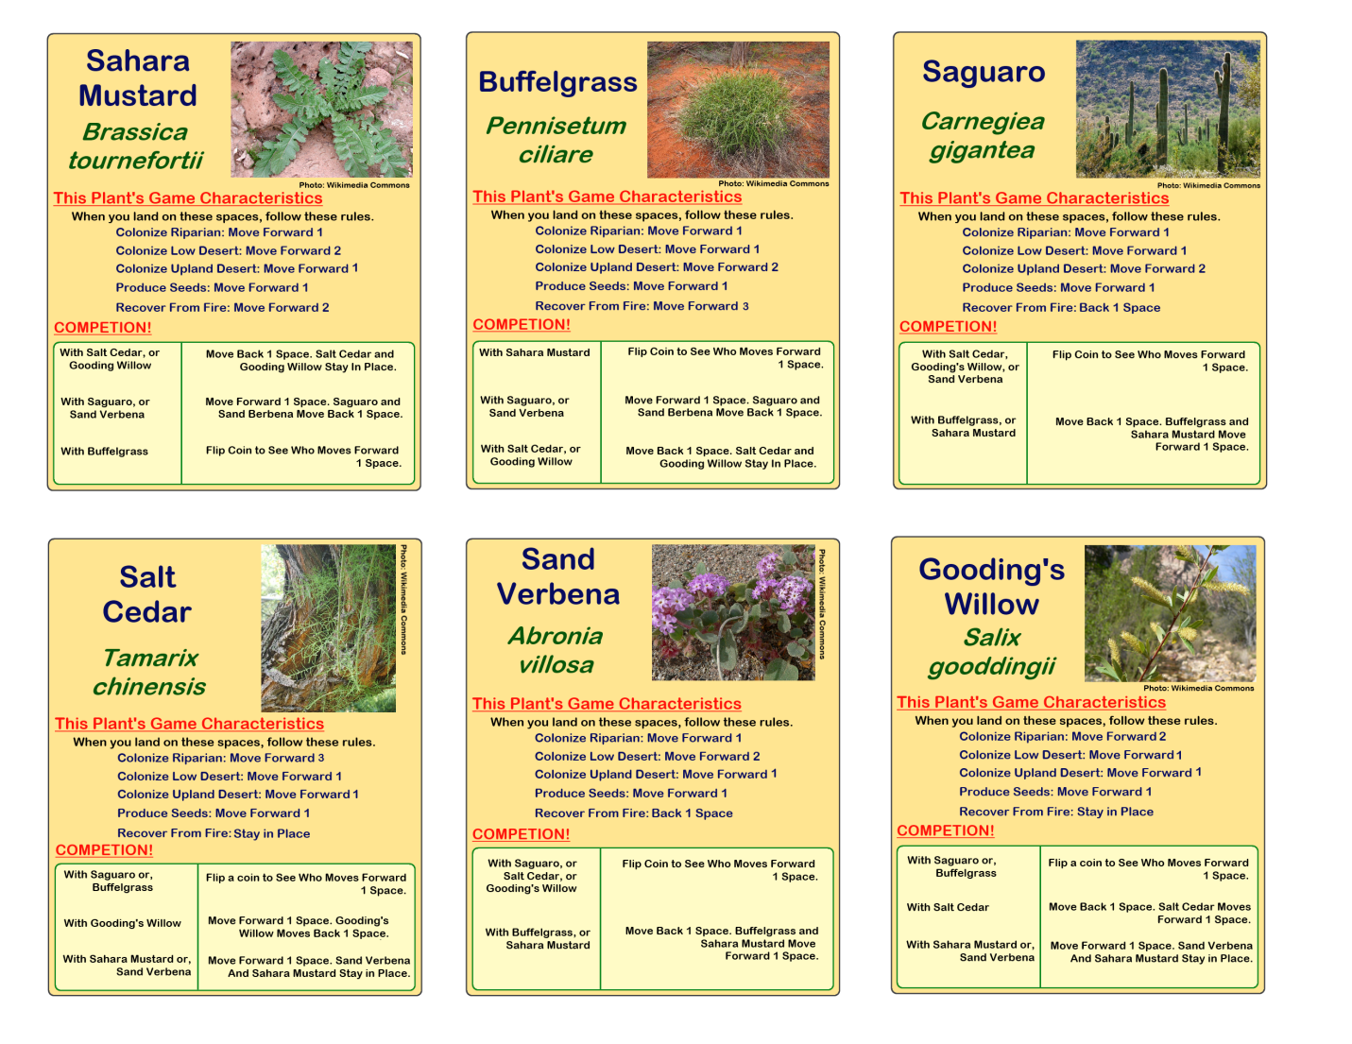
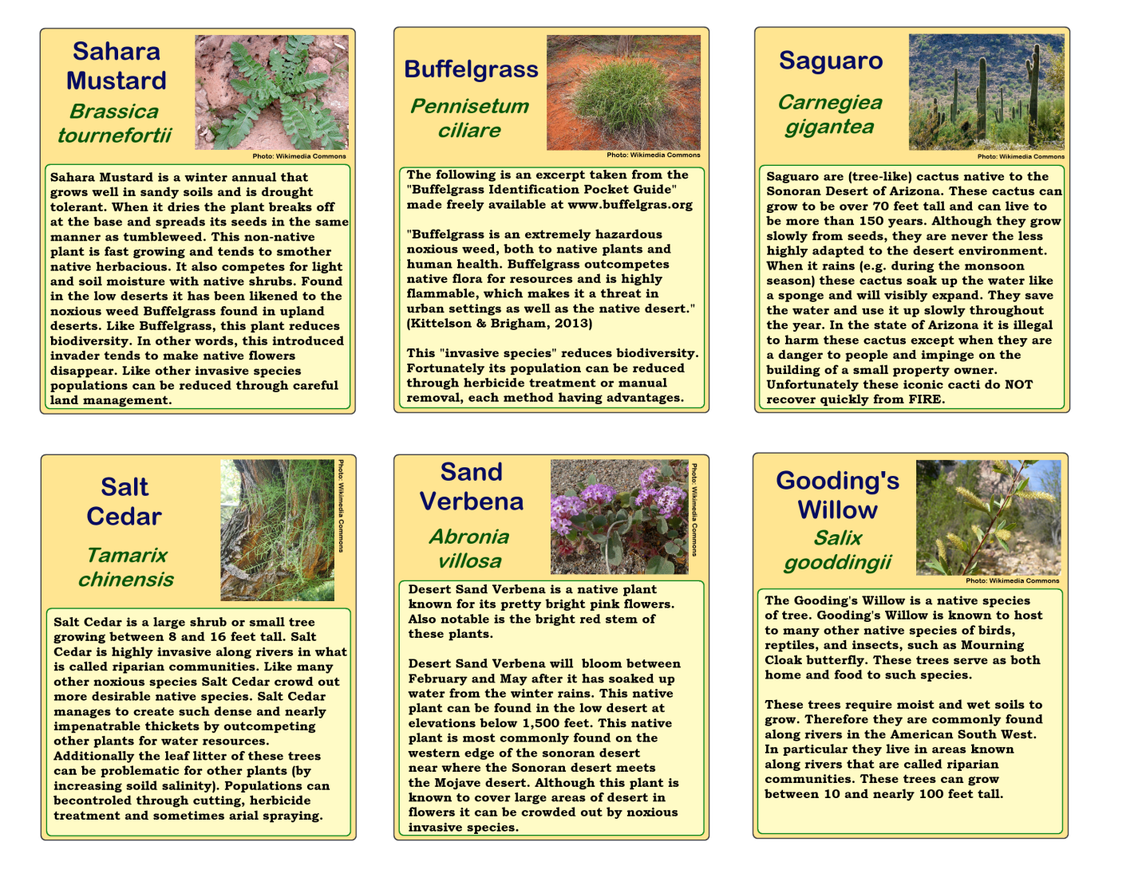

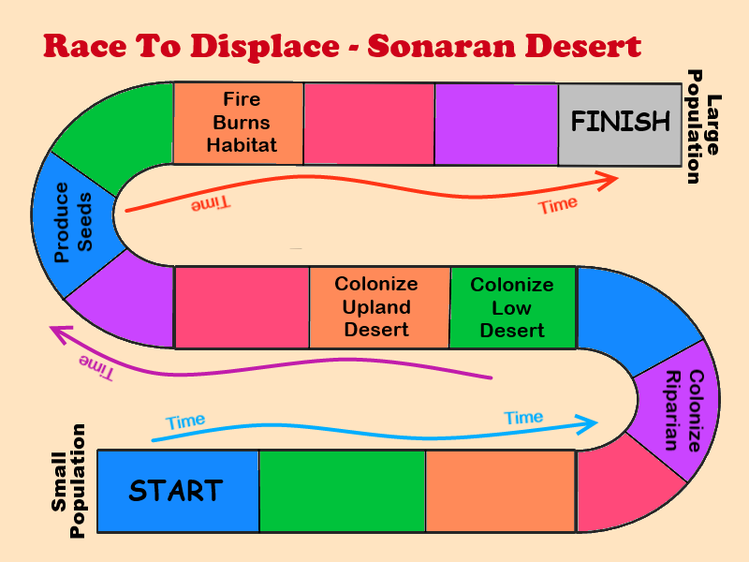
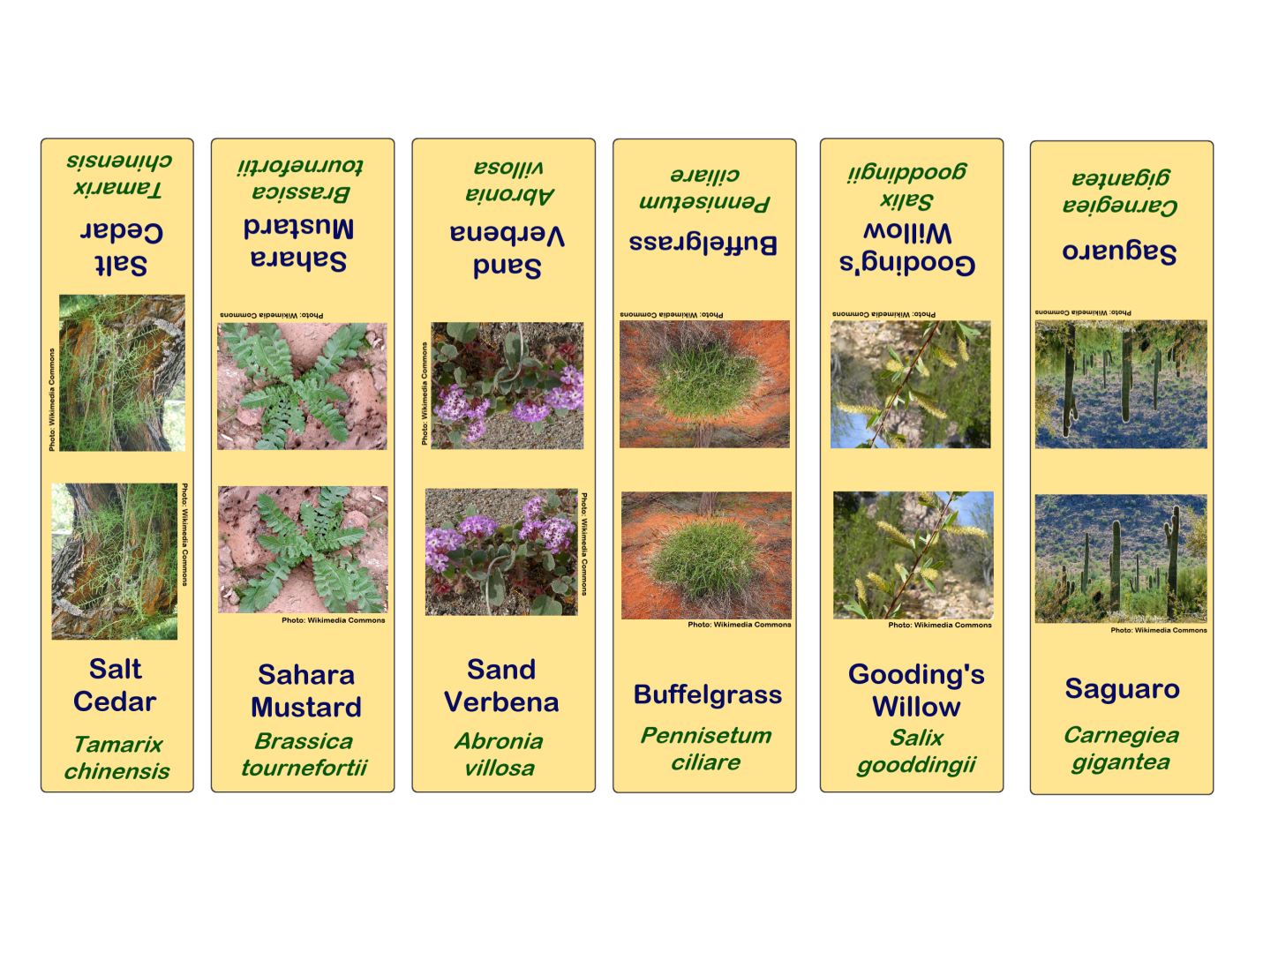

Race to Displace

Playing the Game
(1) Divide students into groups of no more than six. Each student will represent a single plant species.
(2) Distribute the game boards and materials and a Data Sheets to record the results of game play through several trials of the game.
(3) Explain the rules of play to students.

Rules of play:
The object of the game is to be the plant species with the largest population in the community. The species that reaches the finish first has the largest population size and wins. Students should play the game at least three times and track the ranking of each plant in each round.
Optional “management” cards can be introduced after the first three rounds so that students can make comparisons to the results of previous “unmanaged” rounds.

- Each player chooses a Plant Token that represents their species identity for the duration of the game and then
finds the corresponding Plant Information Card and looks it over to briefly become acquainted with their species’ unique characteristics.
- Shuffle the Action Cards and place them near the game board.
- Players draw an Action Card at the beginning of each turn and follow the instructions on it to move around the
board. Turns will occur in the following order: Saguaro, Sand Verbena, Gooding’s Willow, Buffelgrass, Sahara Mustard, and then Salt Cedar.
- When a player lands on a space that contains an event, they should refer to their Plant Information Card, which will tell them how to respond. For example, when the player representing Saguaro lands on a “produce seeds” space, they should move an additional three spaces ahead.
- Some Action Cards are competition cards, which are relevant if two or more players are on the same space. These
players should refer to their Plant Information Cards for direction on how to proceed. For example, if the player representing Chinese lespedeza and the player representing black-eyed Susan are on the same space, they compete, the result being that lespedeza moves forward two spaces and black-eyed Susan moves back one. If a player draws a competition card but is not sharing the space, the player stays in place. If a player is sharing the space with more than one other player, they must compete with each.
- If the Action Cards run out, shuffle and reuse the discarded cards.
- The first player to reach the Finish area wins! After a student reaches the Finish area, have students rank the
plants from the largest populations (those closest to the finish) to the smallest (those closer to the starting point). Use to the Data Sheet.
- Students should play at least three rounds of the game and continue to record plant population rankings from each
round.

(9) “Manage habitat” cards can be introduced after the first three to four trials of the game.

Data Sheet
Species | Trial 1 | Trial 2 | Trial 3 | Trial 4 | Trial 5  (managed) | Trial 6  (managed) | Trial 7  (managed) | Trial 8  (managed)
Saguaro
Sand Verbena
Gooding’s
Willow
Buffelgrass
Sahara Mustard
Salt Cedar

Data Sheet
Species | Trial 1 | Trial 2 | Trial 3 | Trial 4 | Trial 5  (managed) | Trial 6  (managed) | Trial 7  (managed) | Trial 8  (managed)
Saguaro
Sand Verbena
Gooding’s
Willow
Buffelgrass
Sahara Mustard
Salt Cedar

Data Sheet
Species | Trial 1 | Trial 2 | Trial 3 | Trial 4 | Trial 5  (managed) | Trial 6  (managed) | Trial 7  (managed) | Trial 8  (managed)
Saguaro
Sand Verbena
Gooding’s
Willow
Buffelgrass
Sahara Mustard
Salt Cedar

Data Sheet
Species | Trial 1 | Trial 2 | Trial 3 | Trial 4 | Trial 5  (managed) | Trial 6  (managed) | Trial 7  (managed) | Trial 8  (managed)
Saguaro
Sand Verbena
Gooding’s
Willow
Buffelgrass
Sahara Mustard
Salt Cedar

